**SOURCE 1**

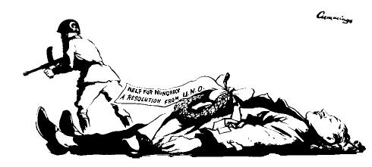

***A British cartoon from 1956.***

**SOURCE 2**

“We have to consider seriously and analyse correctly [the crimes of the Stalin era] in order that we may preclude any possibility of a repetition in any form whatever of what took place during the life of Stalin, who absolutely did not tolerate collegiality in leadership and in work, and who practised brutal violence, not only toward everything which opposed him, but also toward that which seemed to his capricious and despotic character, contrary to his concepts.

Stalin acted not through persuasion, explanation, and patient cooperation with people, but by imposing his concepts and demanding absolute submission to his opinion. Whoever opposed this concept or tried to prove his viewpoint, and the correctness of his position, was doomed to removal from the leading collective and to subsequent moral and physical annihilation. This was especially true during the period following the XVIIth Party Congress [1934], when many prominent Party leaders and rank-and-file Party workers, honest and dedicated to the cause of Communism, fell victim to Stalin's despotism. . . .

Stalin originated the concept enemy of the people. This term automatically rendered it unnecessary that the ideological errors of a man or men engaged in a controversy be proven; this term made possible the usage of the most cruel repression, violating all norms of revolutionary legality, against anyone who in any way disagreed with Stalin, against those who were only suspected of hostile intent, against those who had bad reputations. This concept, enemy of the people, actually eliminated the possibility of any kind of ideological fight or the making of one’s views known on this or that issue, even those of a practical character. In the main, and in actuality, the only proof of guilt used, against all norms of current legal science, was the "confession" of the accused himself; and, as subsequent probing proved, confessions were acquired through physical pressures against the accused.

This led to the glaring violations of revolutionary legality, and to the fact that many entirely innocent persons, who in the past had defended the Party line, became victims. . . .

The Commission [of Inquiry] has become acquainted with a large quantity of materials in the NKVD archive and with other documents and has established many facts pertaining to the fabrication of cases against Communists, to false accusations…….. which resulted in the death of innocent people. It became apparent that many Party, Soviet and economic activists who were branded in 1937-1938 as enemies were actually never enemies, spies, wreckers, etc., but were always honest Communists; they were only so stigmatised, and often, no longer able to bear barbaric tortures, they charged themselves with all kinds of grave and unlikely crimes. . . .

………Stalin, on the other hand, used extreme methods and mass repression at a time when the revolution was already victorious, when the Soviet state was strengthened, when the exploiting classes were already liquidated and Socialist relations were rooted solidly in all phases of national economy, when our Party was politically consolidated and had strengthened itself both numerically and ideologically. It is clear that here Stalin showed in a whole series of cases his intolerance, his brutality and his abuse of power. Instead of proving his political correctness and mobilising the masses, he often chose the path of repression and physical annihilation, not only against actual enemies, but also against individuals who had not committed any crimes against the Party and the Soviet government.

**Nikita Khrushchev (1894-1971), First Secretary of the Communist Party (1953-1964) and Premier of the Soviet Union (1958-1964) delivered the following speech to an unofficial, closed session of the Twentieth Party Congress on February 25, 1956.**

**SOURCE 3**



Edwin Marcus. (1947). Can he block it?. *New York Times*.  Writing over the basket: European Recovery. Writing on the ball: Marshall Plan

**SOURCE 4**

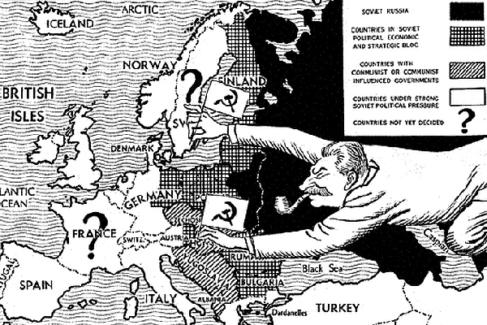

Cartoon from a British newspaper, The Daily Mail, 1947.

*Name: _________________________ Narrogin Senior High School*



**Unit 4, Modern History**

***SOURCE ANALYSIS ONE***

**The Changing European World Since 1945**

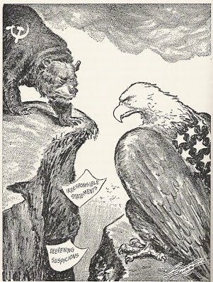

Specific answers will depend on the sources selected by the teacher.

When marking a student’s work:

•not all points necessarily need to be in an answer for the student to gain full marks

•reward each salient point made by the student. Students may make different valid points of interpretation

•students are expected to refer to relevant supporting evidence from the sources.

**Marks out of 25:**

**Weighting: 5 %**

**SECTION ONE: SOURCE ANALYSIS SET 1, Unit 4**

This section has ONE question made up of **FIVE (5)** parts. Attempt **ALL** parts. Write your answers in the spaces provided.

* The marks allocation for this section is 25 marks.
* Allow approximately 45 minutes for this section.

Indicate below the document set from the **Document Booklet** you will use to respond to this

question.

Set 1: □ The changing European world since 1945

Set 2: □ Australia’s engagement with Asia

Set 3: □ The struggle for peace in the Middle East

**Question 1**

1. Explain the historical context of **Source 1**. Include the relevant events, people and ideas depicted or represented in the source. *(3 marks)*

*The historical context of Source 1 (S1) is __________________________________________________________________________________________________________________________________________________________________________________________________________________________________________________________________________________________________________________________________________________________________________________________________________________________________________________________________________________________________________________________________________________________________________________________________________________________________________________________________________________________________________________________________________________________________________________________________________________________________________________________________________________*

*_________________________________________________________________________________________________________________________________________________________________________________________________________________________________________________________________________________________________________________________________________________________________________________________________________________________________________*

|  |  |
| --- | --- |
| **Description** | **Marks** |
| Identifies the focus of the source | 1 |
| Outlines the causes or event that led to the focus of the source | 1 |
| Provides details of the focus of the source, events/people/ideas/dates/places | 1 |
| **Total** | **3** |
| **Note:** This question is concerned with the historical context in which the source is located. Answers should focus on what is in the source and provide the big ‘picture’ for that source. |  |

**(b)** Compare and contrast the purpose of **Sources 1** and **2.** (6 marks)

*The purpose of Source 1 (S1) is to _________________________________________________________________________________________________________________________________________________________________________________________________________________________________________________________________________________________________________________________________________________________________________________________________________________________________________*

*The purpose of Source 2 (S2) is _________________________________________________________________________________________________________________________________________________________________________________________________________________________________________________________________________________________________________________________________________________________________________________________________________________________________________*

*The similarities of purpose between S1 and S2 are _________________________________________________________________________________________________________________________________________________________________________________________________________________________________________________________________________________________________________________________________________________________________________________________________________________________________________*

*S1 and S2 differ in purpose in that S1 is __________________________________________________________________________________________________________________________________________________________________________________________________________________________________________________________________________________________________________________________________________________________________________________________________________________________________________________________________________________________________________________________________________________________________________________________________________________________________________________________________________________________________________________________________________________________________________________________________________________________________________________________________________________*

|  |  |
| --- | --- |
| **Description** | **Marks** |
| Identifies the purpose of the Source 1 | 1 |
| Identifies the purpose of the Source 2 | 1 |
| Identifies elements of comparison between the two sources | 1-2 |
| Identifies elements of contrast between the two sources | 1-2 |
| **Total** | **6** |
| **Note: This question focuses on the reasons for the construction of the sources, and what they aim to achieve. Answers should identify the issue/event/subject of each source; identify the message of the sources; identify the likely purpose for which the source was constructed (or, in the case of the photograph, how the source might have been used, which might produce variations in student interpretation. The response should use evidence from the source to support the response. Lastly, the response should** **explain how they compare (are similar) and contrast (are different) in terms of their purpose.** |  |

**(c)** Identify and explain the message/s of **Source 3**. (3 marks)

*The message of Source 3 (S3) is _________________________________________________________________________________________________________________________________________________________________________________________________________________________________________________________________________________________________________________________________________________________________________________________________________________________________________*

*The message can be explained because*

*__________________________________________________________________________________________________________________________________________________________________________________________________________________________________________________________________________________________________________________________________________________________________________________________________________________________________________________________________________________________________________________________________________________________________________________________________________________________________________________________________________________________________________________________________________________________________________________________________________________________________________________________________________________*

|  |  |
| --- | --- |
| **Description** | **Marks** |
| Explain the message of the source | 3 |
| Outlines the message of the source | 2 |
| Identifies an aspect of the message of the source | 1 |
| **Total** | **3** |
| **Note: Look for the message conveyed by the source. Answers should: consider all of the elements of the source: title/ author/ date/ location; identify the issue/ event/ subject; identify the representation or opinion being expressed; provide evidence from the source to support the response.** |  |

**d)** Identify how and discuss why **Source 3** and **4** are contestable. (6 marks)

*Source 3 (S3) is contestable in that it _________________________________________________________________________________________________________________________________________________________________________________________________________________________________________________________________________________________________________________________________________________________________________________________________________________________________________*

*Source 4 (S4) is contestable in that it _________________________________________________________________________________________________________________________________________________________________________________________________________________________________________________________________________________________________________________________________________________________________________________________________________________________________________*

*_________________________________________________________________________________________________________________________________________________________________________________________________________________________________________________________________________________________________________________________________________________________________________________________________________________________________________*

|  |  |
| --- | --- |
| **Description** | **Marks** |
| Identifies the element/s of contestability for Sources 3 and 4 | 1–2 |
| Discusses the reasons for the contestability of Source 3 | 1–2 |
| Discusses the reasons for the contestability of Source 4 | 1–2 |
| **Total** | **6** |
| Note: The concept of contestability requires a discussion of conflicting historical interpretations represented in source material, specifically why they are different and open to debate. Answers should demonstrate an understanding of what can make a source contestable, whether it provides a certain interpretation of events for which other interpretations exist; or whether the source/s can be disputed as historical evidence. Identify in each source the argument/s, biases, motives or perspectives that can be disputed. Stronger candidates may discuss the nature of the contestability, perhaps by referring to alternative arguments or viewpoints on the interpretations presented by the sources, or by making comparisons between the two sources. |  |

**(e)** Using your knowledge of the whole period of study, evaluate the importance of the

idea of foreign policy represented in the four sources. (7 marks)

*The four sources collectively present elements of _________________________________________________________________________________________________________________________________________________________________________________________________________________________________________________________________________________________________________________________________________________________________________________________________________________________________________*

*_________________________________________________________________________________________________________________________________________________________________________________________________________________________________________________________________________________________________________________________________________________________________________________________________________________________________________*

*_________________________________________________________________________________________________________________________________________________________________________________________________________________________________________________________________________________________________________________________________________________________________________________________________________________________________________*

*_________________________________________________________________________________________________________________________________________________________________________________________________________________________________________________________________________________________________________________________________________________________________________________________________________________________________________*

*_________________________________________________________________________________________________________________________________________________________________________________________________________________________________________________________________________________________________________________________________________________________________________________________________________________________________________*

*_________________________________________________________________________________________________________________________________________________________________________________________________________________________________________________________________________________________________________________________________________________________________________________________________________________________________________*

|  |  |
| --- | --- |
| **Description** | **Marks** |
| Identification of the themes/ ideas/ events | 1 |
| Placement of the themes/ ideas/ events with the themes/ ideas/ events of the broader historical context of the time. Students should be able to demonstrate a breadth and depth of the time period. | 1–2 |
| Evaluation of the themes/ ideas/ events in relation to those of the broader context. | 1–2 |
| Compare and/or contrast with what is in the sources with the other themes/ ideas/ events within the time period. | 1–2 |
| **Total** | **7** |
| Note: This question does not require reiteration of the messages in the sources.  Evaluate the importance of the theme/idea/event in relation to how they are represented in the sources; relates to the other themes/ideas/events of the whole period.  Answers should identify the themes/ideas/events in the sources; evaluate the importance of what is shown in the sources by using evidence from the sources and the whole historical period; refer to the long-term and/or short-term effects of the theme/idea/event; refer to elements of continuity and/or change evident in the theme/idea/event; demonstrate a depth and breadth of knowledge for the whole time period. |  |

Question number:

Question number: